Airline Reservation System

Team Composition (on Title page)

- Ammar Ahmed 20L-0961
- Aun Ali 20L-1300
- Aroob Khalid 20L-1313
- Hassan Bin Zaid 20L-1365
- Muhammad Noor Malik 20L-1349

Abstract

The main purpose of this software is to simplify the tedious task of booking airline tickets by providing this service online in a user friendly environment. It also aims at increasing the efficiency and reducing the drawbacks of existing manual airline reservation process, thus making it more convenient for the customers to book the flights as when they require. This document will tackle the initial phase of this project.

Table of Contents
Team Composition (on Title page) 1
Abstract 2
1. Introduction and Background 4
2. Problem Statement 4
3. Objective(s)/Target(s) 4
4. Completeness Criteria 4
5. Challenges 4
6. Knowledge Areas Required 4
7. Learning Outcomes 4
8. Nature of End Product 4
9. Initial Literature Survey 4
10. Miscellaneous 5
References 5

Introduction and Background
Airline reservation system is aimed at reserving flights for people. Any such system that is operated manually consists of airline employee(s) and customers who interact face to face to reserve the required flight. A major drawback of manual airline reservation system is the need for physical presence of the user at the ticket window. It also requires the employee sitting at the reservation counter to be fast enough to deal with a large number of customers, or the company will have to hire more employees for this purpose.

Problem Statement

Due to the presence of the above discussed drawbacks, there is a need for ARS .
This software interacts with the user to get the details of the flight that he/she wants to reserve. These details include the source and destination city along with the number of passengers, date of the flight and the class by which the user wishes to travel.

Objective(s)/Target(s)

1. FLIGHT DETAILS
2. CHECK AVAILABILITY
3. BOOK TICKET
4. CANCELLATION

Completeness Criteria
This software allows the users to view the availability of various flights on different
dates and time. It gives them the facility to book a ticket, enquire about the total cost,
make online payments and modify or cancel a particular reservation if required.

Challenges
Existing Solutions:
- The existing system involves a lot of paperwork and manual calculation. This
has led to inconsistency and inaccuracy in the maintenance of data.
- The data, which is stored on the paper only, may be lost, stolen or destroyed due to natural calamity like fire and water.
- The existing system is sluggish and time-consuming causing inconvenience to customers and the airline staff.
- Since the number of passengers have drastically increased therefore maintaining and retrieving detailed record of passenger is extremely difficult
Challenges:
The database of the software is not accessible to every user of the software.
Making changes in the database requires permissions that have been given to certain specific individuals.

Knowledge Areas Required

- Database Management Systems
- Fundamentals of Software Engineering
- Introduction to Data Science

Learning Outcomes

Better understanding of SRS documentation procedures, becoming familiar with Web based developer applications and mastering the basic fundamental nature of database management systems.

Nature of End Product
The computerization of the reservation system will reduce a lot of paperwork and hence the load on the airline administrative staff. The machine performs all calculations. Hence chances of error are nil. The passenger, reservation, cancellation list can easily be retrieved and any
required addition, deletion or updation can be performed. The system provides for user-ID validation, hence unauthorized access is prevented.

Initial Literature Survey
Initial studies on existing systems have shown that the existing systems are sluggish and time-consuming causing inconvenience to customers and the airline's staff.

Miscellaneous
There should be an application for reservation and bookings.
We can use data saved in the cloud to mitigate database management

- Introduction to the Document
1.1 - Purpose of the Product
The main purpose of this software is to simplify the tedious task of booking airline tickets by providing this service online in a user-friendly environment. It also aims at increasing the efficiency and reducing the drawbacks of existing manual airline reservation process, thus making it more convenient for the customers to book the flights as when they require. This project is supported by a well-designed DBMS in which flight information is integrated together. A friendly UI is also provided so that the searches made by the user give correct results by accessing the information stored in the database.
1.2 - Scope of the Product
This software allows the users to view the availability of various flights on different dates and time. It gives them the facility to book a ticket, enquire about the total cost, make online payments and modify or cancel a particular reservation if required.

1.3 - Acronyms, Abbreviations, Definitions

- ARS - Airline Reservation system
- UI - User Interface
- DBMS - Database Management System
- SRS - Software Requirements Specification
- ID - Identifier

1.4 - References
Software Engineering: A Practitioner’s Approach by Roger S. Pressman
An Integrated Approach to Software Engineering by P. Jalote

1.5 - Outline of the rest of the SRS
The rest of the document deals with all the main features of this software. It not only describes various functions but also gives details about how these functions are related to each other. Various risks associated with the system have also been mentioned along with the ways to mitigate them. A flow graph (Nan) will also be generated. Both functional and non-functional requirements will be discussed as well as the interface will be provided.

- General Description of Product
2.1 - Context of Product
Current state of manual reservation systems is as follows:

- The existing process involves lots of paper work and manual calculation. This has led to inaccuracy, inconsistency and poor maintenance of data.
- The data is stored on paper, which can be lost, stolen, misplaced or destroyed due to disasters.
- Existing process is slow and has a long wait associated with it, hereby causing an inconvenience to the airlines staff and customers.
Hence the ARS is proposed with following Product Perspective:
- Computerization of the current system will reduce paperwork and load on the airline booking and administrative staff.
- Machine will handle all calculations and checks; the chance of wrong info is none.
- Passenger reservation, cancellation and cancellation list will be retrieved and required changes (addition, deletion, updating) can be performed.
- The ARS will provide user-ID validation and unauthorized access will be denied

2.2 - Product Functions
This software is a web-based ARS. Various UI will be used in relation to this software. They will help user to interact with this software and provide the necessary information for online ticket reservations.

2.2.1. Flight Details
The software shall allow the user first enters the details of his journey: source, destination, date, number of passengers and time.

2.2.2. Check availability
This software shall check the availability of flights based on input given by the user in module 2.2.1.
2.2.3. Book ticket
This software shall allow the user to book the ticket after checking the availability by module 2.2.2. A maximum of five passengers will be allowed to book at a single time.
2.2.4. Cancellation
This software shall be used by the user to cancel his reservation. The user will enter the distinct ID assigned to him after reservation. Using this ID, he shall cancel his tickets.

2.3 - User Classes and Characteristics
- User of this software must be comfortable working with the English language.
- User must have a basic knowledge of computers.
- Typical users will be the customer handling their booking.
- Advanced / Upper-level users will be the airline staff uploading / maintaining the database with new flight data.
- Programmers who are interested in working on the ARS by further developing it or fix existing bugs

2.4 – Constraints
Not every user of the software does not have access to the software's database. Changes to the database necessitates the use of permissions granted to certain users.
2.5 - Assumptions and Dependencies
The ARS is assumed to be compatible with computer systems on which it has been loaded for customer use.
- Specific Requirements
3.1 External Interface Requirements

3.1.1 User Interfaces

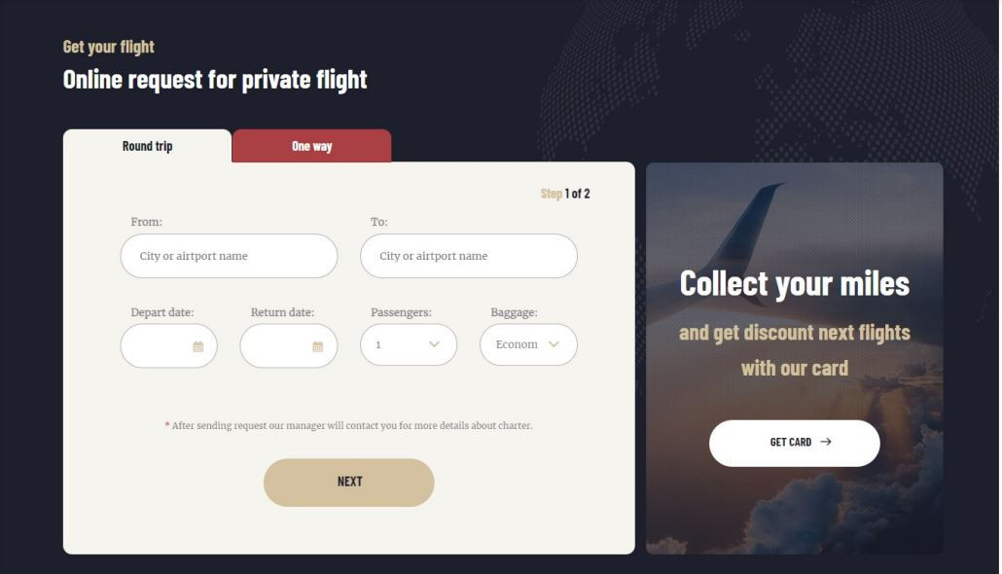

3.1.2 Hardware Interfaces
No hardware interface is required for the Airline Reservation system.
3.1.3 Software Interfaces
ARS should be a web-based system. It should be possible to open and use the website on the computers with operating systems of Microsoft 7, Microsoft 8, Microsoft 10, Mac Os, Linux, Ubuntu.

3.1.4 Communications Interfaces
HTTP protocol should be used as an interface of communication between client and server sides.
3.2 Functional Requirements
3.2.1 Requirement 1
Customer should be able to specify the travel class while searching for a flight
3.2.2 Requirement 2
Customer should be able to sort the list of possible flights by price and flight duration.
3.2.3 Requirement 3
Customer should be able to select the type of the ticket.
3.2.4 Requirement 4
Customer should be able to select the names of departure and arrival cities from the list of all flight offered cities.
3.2.5 Requirement 5
Customer should be able to request reservation cancellation
3.2.6 Requirement 6
System should allow customer to book tickets for maximum of 6 people.

3.3 UML-Use Case Diagram
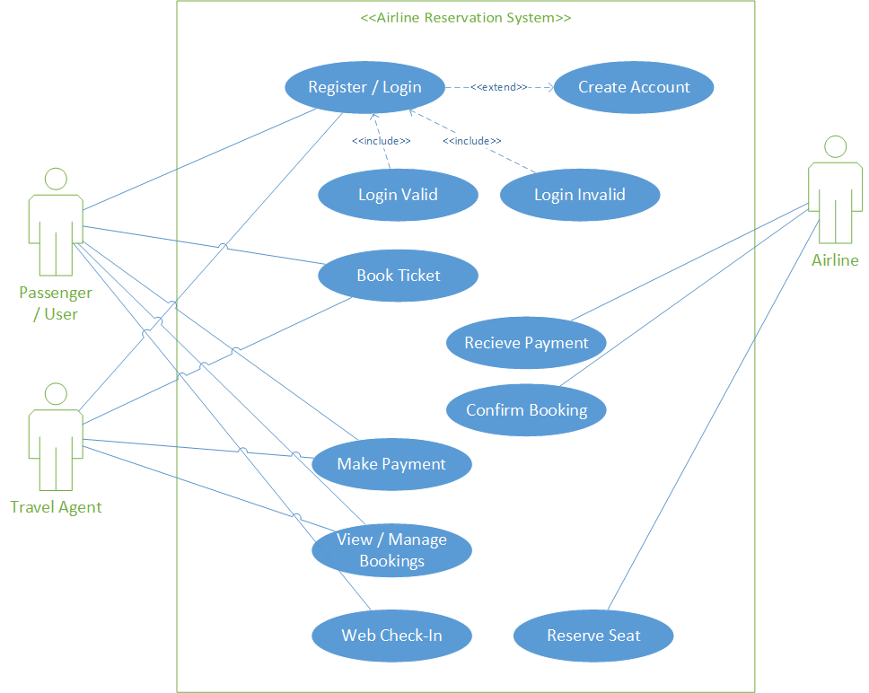

3.4 Performance Requirements
System should be able to handle 1000 transactions per second.
3.5 Design Constraints
Flight dates and hours should be displayed according to the city of departure and destinations’ time zones and the daylight saving time settings for each country should be considered. Additionally, information about any changes that are made in the DBMS should be displayed with no delay.
3.6 Other Quality Requirements
User should be displayed acceptance message within 5 seconds, when he/she submits entered data to the system. System should be manageable in web-browsers of Internet Explorer, Google Chrome, Mozilla Firefox, Opera and Safari.

3.7 Other Requirements
System should display a warning message if the customer input for full name label is out of defined standard. System should display a warning message if the customer input for travel document number is out of defined standard. System should display a warning message if the customer wants to book flights for more than 6 people.
References:
Software Engineering: A Practitioner’s Approach by Roger S. Pressman,
An Integrated Approach to Software Engineering by P. Jalote,
Udemy
https://en.wikipedia.org/wiki/Airline_reservations_system

The “Call and Return” Architecture has been adopted for the ARS(Airline Reservation System), due to its simplicity in managing submodules, each module calls its submodule for confirmation and the process then continues.
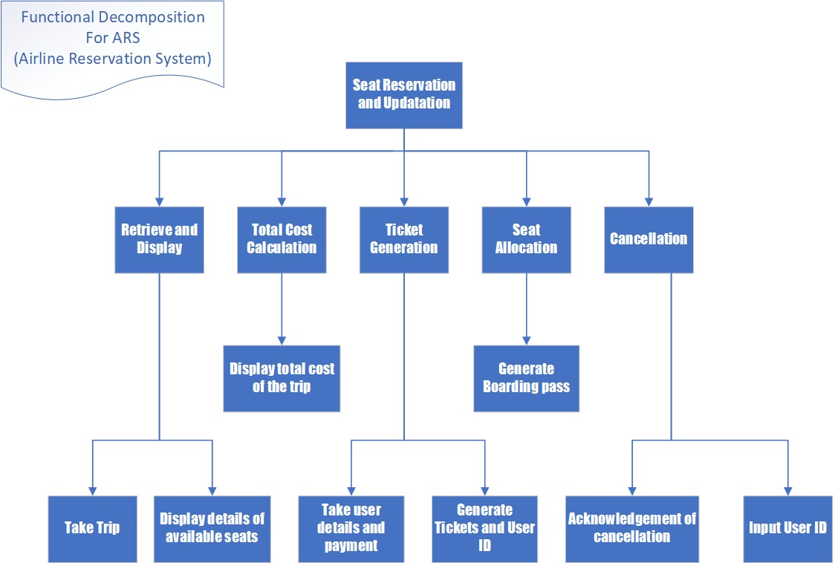
Functional decomposition is used to decompose / divide steps into subfunctions and smaller parts which help break down the overall process.
The diagram is shown in a top-down format illustrating a process. A functional decomposition diagram contains the overall function or task as well as the necessary sub-functions or tasks needed to achieve the overall objective.

The following Gantt Chart provides the expected timeline of the project
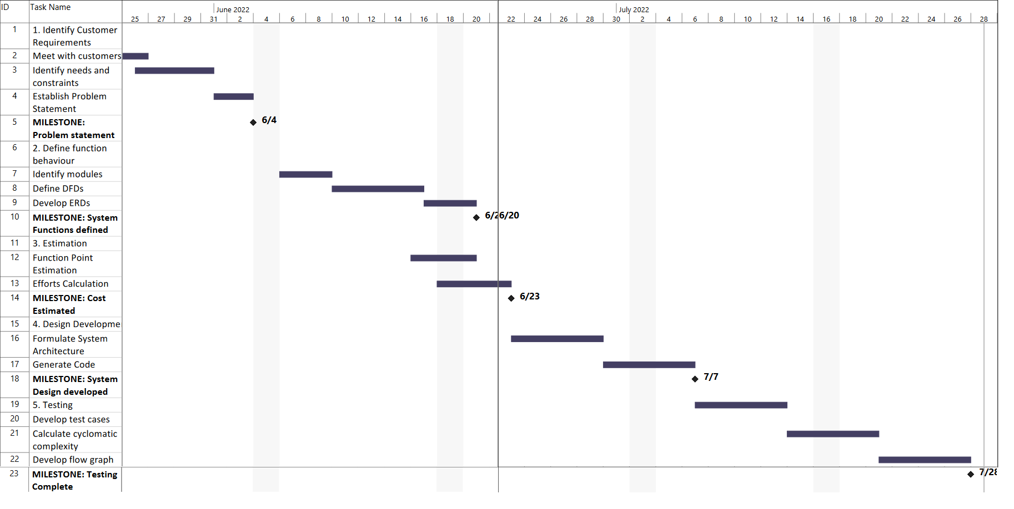
Activity / Work Item /Task | Assigned to | Performed by | Remarks
Interface and Problem Statement | Aun Ali - 20L-1300 | Aun Ali – 20L-1300 | Aun Ali had a little bit knowledge of wordpress
Gantt Chart | Ammar Ahmed– 20L-0961 | Ammar -20L-0961 | Ammar new how to make Gantt Chart on MS Project
SRS | Aroob Khalid – 20L-1313  Hassan bin Zaid – 20L-1365 | Aroob Khalid – 20L-1313  Hassan bin Zaid – 20L-1365
Architecture | Muhammad Noor Malik – 20L-1349 | Muhammad Noor Malik – 20L-1349
The approximate completion time is 10 weeks in this project.

